**Total Labour Costs per Head trials with:**

1. Unemployment

Call:

lm(formula = labourcosts ~ unemployment, data = test)

Residuals:

Min 1Q Median 3Q Max

-5064 -2311 -1149 1614 20846

Coefficients:

Estimate Std. Error t value Pr(>|t|)

(Intercept) 20918.49 2765.81 7.563 0.0000000196 ***

unemployment 54.42 345.17 0.158 0.876

---

Signif. codes: 0 ‘***’ 0.001 ‘**’ 0.01 ‘*’ 0.05 ‘.’ 0.1 ‘ ’ 1

Residual standard error: 4636 on 30 degrees of freedom

Multiple R-squared: 0.0008277, Adjusted R-squared: -0.03248

F-statistic: 0.02485 on 1 and 30 DF, p-value: 0.8758

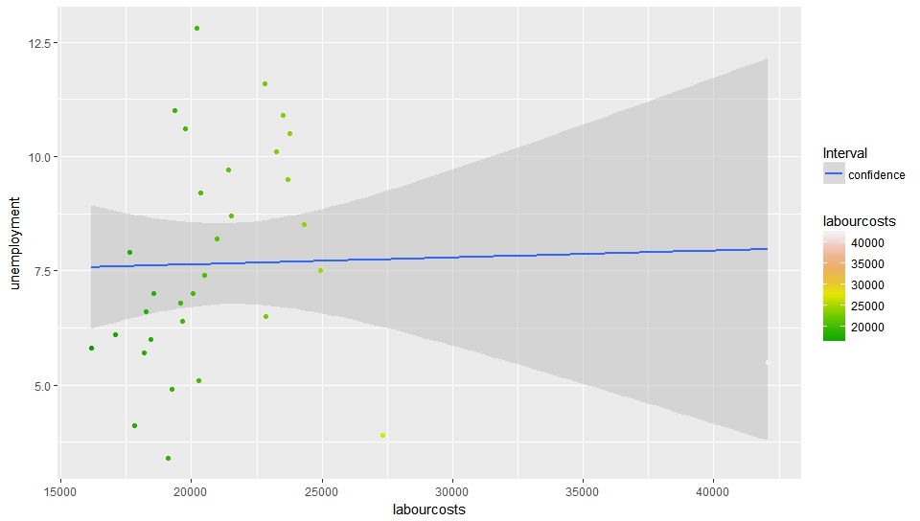

1. Degree Holders Ratio

Call:

lm(formula = labour2011 ~ degreeratio2011, data = test)

Residuals:

Min 1Q Median 3Q Max

-6143.2 -2362.4 -669.1 1486.4 20016.4

Coefficients:

Estimate Std. Error t value Pr(>|t|)

(Intercept) 19176.6 2706.8 7.085 0.0000000706 ***

degreeratio2011 102.2 122.3 0.836 0.41

---

Signif. codes: 0 ‘***’ 0.001 ‘**’ 0.01 ‘*’ 0.05 ‘.’ 0.1 ‘ ’ 1

Residual standard error: 4584 on 30 degrees of freedom

Multiple R-squared: 0.02275, Adjusted R-squared: -0.009824

F-statistic: 0.6984 on 1 and 30 DF, p-value: 0.4099

1. Employment Ratio

Call:

lm(formula = labour2011 ~ employmentratio, data = test)

Residuals:

Min 1Q Median 3Q Max

-5300.1 -2199.8 -871.5 877.6 20255.3

Coefficients:

Estimate Std. Error t value Pr(>|t|)

(Intercept) -6065.2 16386.5 -0.370 0.714

employmentratio 376.2 224.7 1.674 0.105

Residual standard error: 4435 on 30 degrees of freedom

Multiple R-squared: 0.08543, Adjusted R-squared: 0.05495

F-statistic: 2.802 on 1 and 30 DF, p-value: 0.1045

1. Total Earning Ratio

Call:

lm(formula = labour2011 ~ earnmedian, data = test)

Residuals:

Min 1Q Median 3Q Max

-7158.8 -2003.9 -316.6 1506.5 13081.9

Coefficients:

Estimate Std. Error t value Pr(>|t|)

(Intercept) -10924.82 7492.93 -1.458 0.155226

earnmedian 68.14 15.77 4.321 0.000157 ***

---

Signif. codes: 0 ‘***’ 0.001 ‘**’ 0.01 ‘*’ 0.05 ‘.’ 0.1 ‘ ’ 1

Residual standard error: 3641 on 30 degrees of freedom

Multiple R-squared: **0.3837**, Adjusted R-squared: 0.3631

F-statistic: 18.67 on 1 and 30 DF, p-value: 0.0001568

1. Smokers percent

Call:

lm(formula = labour2012 ~ smoking2012percent, data = test)

Residuals:

Min 1Q Median 3Q Max

-4680 -2624 -1441 1093 21617

Coefficients:

Estimate Std. Error t value Pr(>|t|)

(Intercept) 18174.5 4276.3 4.250 0.000191 ***

smoking2012percent 175.2 191.8 0.913 0.368263

---

Signif. codes: 0 ‘***’ 0.001 ‘**’ 0.01 ‘*’ 0.05 ‘.’ 0.1 ‘ ’ 1

Residual standard error: 4893 on 30 degrees of freedom

Multiple R-squared: 0.02706, Adjusted R-squared: -0.005368

F-statistic: 0.8345 on 1 and 30 DF, p-value: 0.3683

1. Pay Gap Ratio

Call:

lm(formula = labour2011 ~ paygap2010ratio, data = test)

Residuals:

Min 1Q Median 3Q Max

-4702 -2734 -1317 2095 19035

Coefficients:

Estimate Std. Error t value Pr(>|t|)

(Intercept) 20346.7 1334.1 15.251 0.000000000000036 ***

paygap2010ratio 176.5 125.2 1.409 0.171

---

Signif. codes: 0 ‘***’ 0.001 ‘**’ 0.01 ‘*’ 0.05 ‘.’ 0.1 ‘ ’ 1

Residual standard error: 4676 on 25 degrees of freedom

(5 observations deleted due to missingness)

Multiple R-squared: 0.07358, Adjusted R-squared: 0.03652

F-statistic: 1.985 on 1 and 25 DF, p-value: 0.1711